Station 3 - SCBD

Candidate instructions:
This station is a Standardised Case-Based Discussion. You will be interacting directly with an
Examiner. You will be asked to outline your assessment and management to the following
clinical situation.
Further information will be provided as the case evolves. The examiner will be
assessing your medical knowledge as well as your reasoning and rationale to your approach and
decisions.
Please be as specific as possible when answering. For example, when discussing drugs, describe
your dosage regimen and the reasons why you chose that regimen, as opposed to other
Regimens.

Case Information:
You are a consultant in a tertiary emergency department. A 31 year old man presents with 6
hours of severe central chest pain, in the background of a flu-like illness over the last week.

Vital signs at presentation:
HR 60 bpm
BP 100/60 mmHg
RR 35 /min
O2 sat 93% room air
Temp 37.5 deg

He is triaged to the resuscitation area. A 12-lead ECG is taken (provided on page 2)

Your task:
1. Describe and interpret the ECG.
2. Answer any further questions from the examiner.

Domains examined:
Medical Expertise (60%)
Prioritisation and Decision-making (40%)

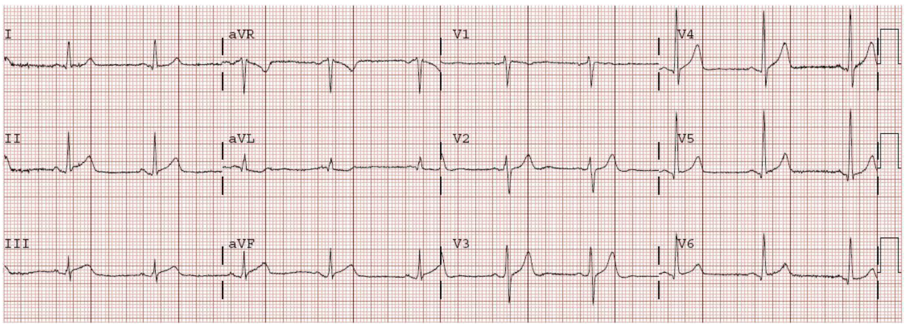

Examiner instructions
SCENARIO
You are a consultant in a tertiary emergency department. A 31 year old man presents with 6 hours of severe central chest pain, in the background of a flu-like illness over the last week. Vital signs at presentation: HR 60/min, BP 100/60 mmHg, RR 35/min, O₂ Saturation 93% on room air, Temperature 37.5ºC He is triaged to the resuscitation area. A 12-lead ECG is taken (included in stem).
Question 1: (1.5 mins) Describe and interpret the ECG (incl in stem)
Expected Response | Details & Comments
12 Lead ECG | Sinus rhythm, approx. 60 bpm
Infero-lateral ST elevation -1 mm, concave upwards laterally.
PR segment depression, most obvious in inferior leads
Relevant negatives | Normal axis, no ectopics, QTc looks within normal range
Differential diagnosis | Acute Pericarditis, Myocarditis, Myocardial infarct less likely  High take-off – normal variant
Interpretation | Young patient with clinical and ECG features suggesting acute pericarditis. Borderline fever and Hypoxia, and hypotension are a concern – distributive or restrictive shock. Needs urgent cardiac Ix.

Question 2: (1.5 mins) His blood pressure subsequently falls to 85/50. His pulse is 110 and he is increasingly dyspneic and still has chest pain. Outline your approach to this patient.
Expected Response | Details & Comments
Cardiovascular  compromise | Shock: Cardiogenic / obstructive ; septic  ? Pericardial effusion with tamponade.  ? Myocarditis-cardiomyopathy  ? Aortic dissection  Other: PE, Pneumonia with incipient septic shock,
Clinical features | Hx – Pericarditis sx, other risks ie ischemia, IVDU, autoimmune etc  Exam – JVP, Lungs, heart sounds, periphery, septic focus, (ie LVF, Tamponade etc)
Bedside Investigations | ECG monitoring; Repeat 12-lead ECG, ABG, BSL  Urgent CXR  Bedside echo – volume, tamponade, LV function global or local, valves  Prompt ± What is the role of bedside ultrasound?
Initial Management | Depending upon dx.  Consider IV fluid bolus; titrated narcotic analgesia; supplemental O_{2, ,}BiPAP
Definitive / Disposition | Formal echocardiogram  Pending outcome of initial findings  Requires admission, likely CCU or HDU/ICU  ? Cath Lab – Balloon pump etc
Pathology | FBE, Troponin, UEC

Question 3: (2 mins) The patient continues to deteriorate despite initial Mx. Your findings are of cardiogenic shock from severe myocarditis, without pericardial tamponade. Describe your technique to intubate this patient
Expected Response | Details & Comments
Equipment | BVM device, suction, laryngoscope, ETT size 7.5 or 8; oropharyngeal airway; ventilator
Drugs | Cardiostable induction drugs: SENSIBLE  Optimise hemodynamic state with commencement of low dose aramine or adrenaline prior to induction. Cardiostable sedation maintenance - fentanyl/midaz.  Ongoing muscle relaxation.
Induction / Intubation | Pre-oxygenation, positioning, cricoid pressure
Post intubation | Confirmation of tube positioning: bedside methods (incl capnography), CXR
Ventilation settings | ETT Ventilator settings: 5 ml/kg TV, RR 15, minimal PEEP, FIO₂ 1.0  Titrate to clinical and ABG parameters
Maintenance | Ongoing sedation and muscle relaxation and hemodynamic support  Gastric tube

Question 4: (2 mins) Soon after successful intubation Whe paWienW¶V BP is 60/40 mmHg. Outline your approach to the hypotension.
Expected Response | Details & Comments
Confirm BP
Check rhythm
Check induction drugs | Side effects, correct dose and drug, allergy etc
Examine patient | Chest – trachea, air entry, bronchospasm, rash
Check ventilator | Disconnect and hand ventilate, check circuit and settings etc
Repeat tests | ECG, CXR, echo, electrolytes
Antiarrhythmic drugs as needed | Amiodarone?
Fluid | As required
Inotropic support | Adrenaline/aramine boluses if recalcitrant hypotension, followed by infusion. Aim for normotension (MAP > 75mmHg).
Other | Specific Rx: ? corticosteroids  Refer to ICU / cardiology  Consider IABP/VAD if refractory shock  Retrieval and transfer prn

