Station 4 - Teaching

You are a consultant in a mixed urban ED. Your house officer observed a 7 year old girl being
administered nitrous oxide to facilitate the insertion of an IV cannula earlier in the shift. The
house officer would like to know about how to use it.

Your tasks:
- Teach the house officer the clinically important features of a nitrous oxide delivery circuit
- Teach them how to prepare the circuit for use
- Teach them the indications for using nitrous oxide in the emergency department

The following equipment will be available in the examination room.
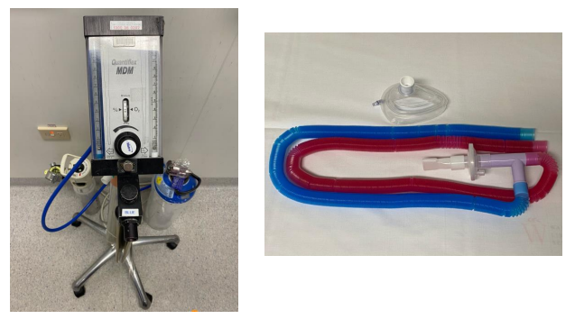

Domains assessed:
- Medical expertise 60%
- Scholarship and teaching 40%

