Station 2 - Physical Exam
This station is a Physical Examination. You will be interacting directly with an
Examiner. You will be asked to outline your focussed examination and management to the following clinical situation.
Further information will be provided as the case evolves. The examiner will be
assessing your medical knowledge as well as your reasoning and rationale to your approach and Decisions.
Please explain to the examiner in detail how you would examine this patient, and answer any questions from the examiner.

Candidate Instructions:
Case information:
You are in charge of a tertiary metropolitan ED during a weekday shift.
You are managing a 24 year old male who weighs 70kg.

He is 5 hours post ingestion of:
- 20 x 40mg Citalopram
- 5 x 50mg Tramadol
- 200mls of vodka
He has been brought to ED by his girlfriend.

His initial vital signs are:
Temp 38.2 degrees
HR 120
BP 170/90
RR 22
O2 sats 99% on room air
GCS 14 - confused

Your tasks:
- Explain to the examiner your focussed examination of this patient
- Outline your management of this patient as you receive further information about the case

Domains examined:
Medical Expertise
- Physical Examination (50%)
- Management (30%)
Prioritization and Decision Making 30%

Examiner Instructions:
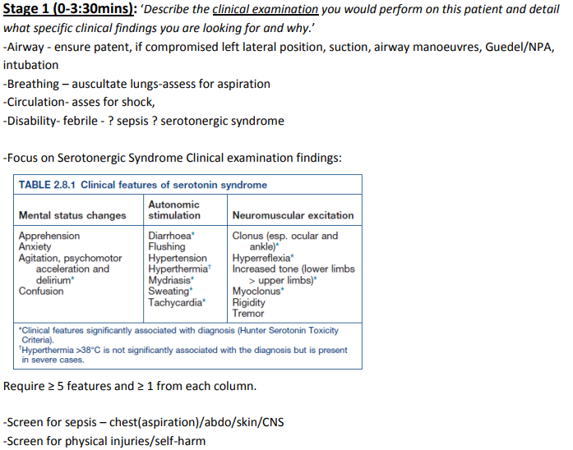

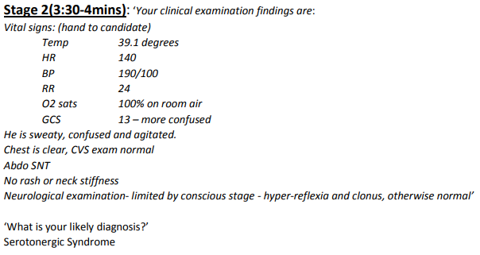
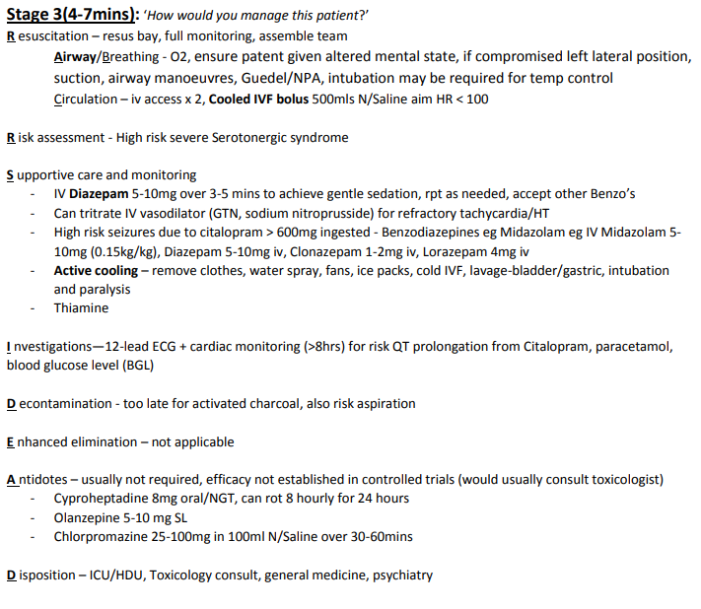

Marking criteria
